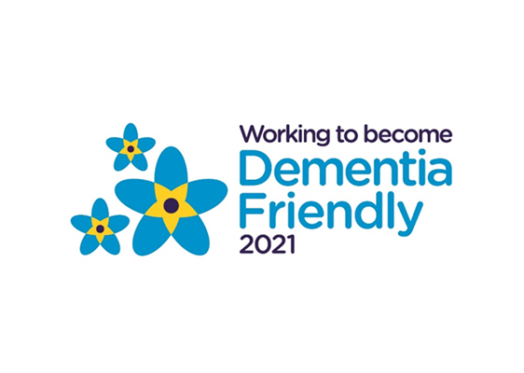

South Ribble Dementia Charter
As a Dementia Friendly Community, we are committed to ensuring people with dementia feel understood, valued and are able to contribute to their community

Our group/organisation commits to support those
in our community who live with Dementia

We aim to ensure

Members of our group/organisation become Dementia Friends

When we consider new policies or strategies we will make sure people living with Dementia are considered

Our place of business/work is friendly and welcoming and we consider the way it is designed/looks to help people with Dementia have a positive experience

Any events we hold, we make sure we consider the needs of people living with Dementia so that they are able to fully participate in community life

How to Sign Up to the Charter

Below is some guidance on how you can become a Charter Member.
You will be provided with an application form.

- You need to provide evidence that members of your organisation have undertaken the Dementia Friend Sessions. This can be done in two ways;

- Online at www.dementiafriends.org.uk/register-digital-friend
- Request a Dementia Champion to provide a FREE session at your organisation. You can request these by contacting the alliance at louise.davies@southribble.gov.uk

- Please use the below application to demonstrate how your organisation is currently or is working towards;

- Ensuring policies/strategies are developed so that they can support people living with Dementia accessing your services, as employees who may have caring responsibilities

- Ensuring your organisation is a place that is welcoming to people with Dementia, e.g. have you changed the layout of your reception or shop, do you ensure dementia friends are on hand to support people

- That If you hold events, open days, and or offering volunteering opportunities; people living with Dementia are able to take part in an active way and or events have been designed in a way that supports them being able to come along and participate

The list above is not exhaustive but gives an indication of how you can meet the aims of our Charter. You may not feel each area is relevant to your organisation, if so please tell us so that we understand why that area is not being addressed.

At the heart of this Charter, we want to ensure anyone living with dementia, their carers and their families have the confidence to take an active part in community life and that we as a community understand, respect and can support those individuals in South Ribble.

On becoming a Charter member you will be listed in our ‘Living Well Guide’ and receive a sticker to place in your window to show that you are a Dementia Friendly member of South Ribble’s Dementia Action Alliance.

South Ribble Dementia Charter

Please complete the below questions to demonstrate how your organisation currently and/or working towards being Dementia Friendly.

Dementia Friends

- Have you undertaken a Dementia Friends Session? | Yes |  | No
- If no, do you plan to? | Yes |  | No
- If yes, when do you plan to do this? (date)
- How many Dementia Friends do you have in your organisations/group?
- Do you commit to having new employees undertake Dementia Friends session? | Yes |  | No

Championing Dementia
- Do you have a Champion/Dementia Lead within your organisation who is responsible for ensuring the organisation working towards Dementia Friends objectives?  If yes, who is this person and how can we contact them? | Yes |  | No
- If no, do you plan to? | Yes |  | No
- If yes, when do you plan to do this? (date)
What areas will you focus on or have already developed? (Not all are required to be complete, however at least one is).

- All policies are Dementia Friendly | Yes |  | Working Towards
- Our buildings or spaces are designed to be Dementia Friendly | Yes |  | Working Towards
- We will support all employees to become Dementia Friends | Yes |  | Working Towards

- Would you like us to put you in contact with a Dementia Friendly business already operating as a Dementia Friendly business? Yes No

Please tell us a little more about how you have achieved the above and what you intend to do throughout the next year to build on this. Please give as much details as possible:

Examples from other Charter members:

- Removing dark/black mats from entrance areas (as these can be perceived to be holes).
- Making reception areas a simple layout to avoid confusion.
- Making becoming a Dementia Friend a part of the induction process for new starters.
- Having seating available for those who aren’t able to stand for long periods.
- Championing the Dementia Charter amongst other local businesses.
- Having HR policies in place to support employees living with dementia.

Contact Details
Your Name
Position in Organisation
Organisation
Email:
Phone:

By Signing up to this Charter you understand that;

- You commit to the principle of this Charter

- Your organisation will be listed in South Ribble Living Well Guide as a Dementia Friendly service/place. Please indicate below that you consent for us to list you.

- I Consent for you to list our organisation, address and public contact details in the Living Well Guide for the purposes of showing us as a member of the Charter

- You are duly authorised by your organisation to submit this application

- The South Ribble Dementia Action Alliance has the right to accept, refuse or remove the Charter status at any time; however any organisation that has the application refused, or an existing status removed will be informed of the reasons why that action has been taken.

Contact Permission
We would like to stay in touch and give you updates about the work of the Dementia Action Alliance and we would like to do this by email.

We will always treat your personal details with the utmost care and will never provide them to any third party.

Please let us know if you would like to be contacted by us for the purpose of receiving updates from South Ribble Dementia Action Alliance (managed by South Ribble Borough Council)

Yes please, I’d like to hear about the latest updates and information from South Ribble Dementia Action Alliance

